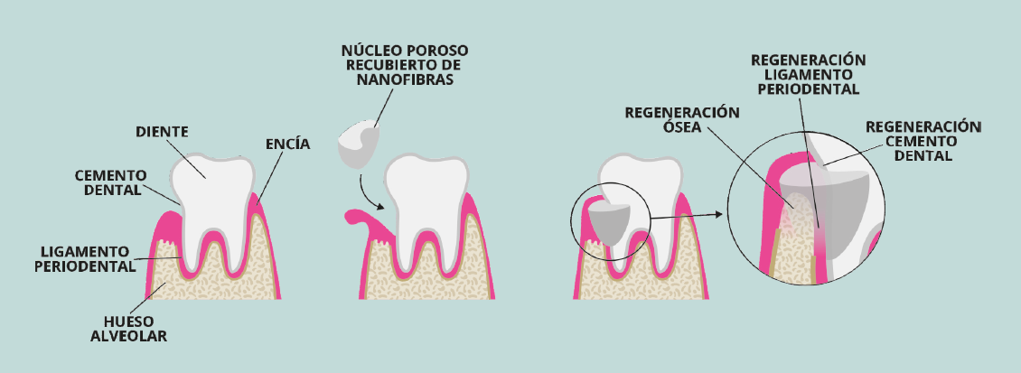

ALVEOLAR BONE PERIODONTAL LIGAMENT DENTAL CEMENT TOOTH GUM

POUROUS NUCLEUS WITH NANOFIBRE COATING

BONE REGENERATION REGENERATION OF THE PERIODONTAL LIGAMENT REGENERATION OF THE DENTAL CEMENT